“Walking the Talk”
Not long ago I was listening to the radio and I heard a song that I thought had to be a new track from one of my favorite bands of all time. I could not imagine how this band had released a new song or album and I did not know about it. I went online to find the station’s playlist. It turned out to be a band I had not heard of. I had to find out more. After a little investigation I learned that this musician I had never heard of was actually riffing on my favorite band. He was intentionally copying them. My ears had not fooled me.
The point is that we often relate something new to another thing we have already experienced. That is why Meyer Hawthorne reminds me of Steely Dan or artist Daniel Wall reminds me of Monet or author Paulo Coelho reminds me of Ernest Hemingway.
This mental categorizing is not just for musicians, painters and writers; we also use it for people in our day to day life. So when Jesus asks his disciples “Who do people say that the Son of Man is?” Their responses should not be taken literally. When the disciples tell Jesus that some say he is John the Baptist they do not mean that people think he is John the Baptist reincarnated. Rather that there is something about Jesus that reminds them of John the Baptist. It could be that Jesus’ being an itinerant preacher reminds them of John. Those that compare Jesus to Elijah might be focusing on the miracles, especially the healing miracles both of them performed. With Jeremiah the comparison may lie in the prophetic pronouncements about the future that characterize the teachings of each of them.
Then Jesus turns the tables and asks the twelve disciples, “But who do you say that I am?” The ever impulsive and hard to restrain Peter blurts out “You are the Messiah, the Son of the living God.” Jesus then blesses Peter or Petros in Greek and says that he will be the rock or petras on which the church is built. It is a powerful moment. Much of Christian history and certainly the early church is shaped by this one moment when Peter is given the keys to the kingdom and made the foundation of the church. But I think for you and me in this moment the salient point is not Peter’s response but our response to the question, “Who do you say that I am?”
This question, like many of Jesus’s questions, is not just directed at the twelve disciples. This question is directed at all people throughout the ages, not the least of which are you and me. Our answer is important. For if we take our response to heart and live into it we will be changed forever.
As many of you are aware, I have deep admiration for St. Francis of Assisi. He was a privileged young man whose life was all laid out for him by his father. He was to be a gallant soldier who fought against Assisi’s enemies. He was to earn glory on the battlefield and be a leader of Assisi. Francis liked the privilege, but did not want the responsibility. He was much more successful as a party boy than a knight. He enjoyed the social life and spending his father’s money on food and drink. Going to war was not his forte. He ended up in a prison and had to be ransomed.
He returned to his carefree life, but a subsequent attempt at taking up arms, ended with him leaving the expedition before the battle. He became more reflective and somber. He wandered the countryside or kept to himself. One day he came across the crumbling church of San Damiano. There he prayed to the cross and Jesus responded to him saying, “Rebuild my church.”
Francis was lots of things but the brightest bulb in the pack was not one of them. He took Jesus to mean, “Rebuild this particular church.” Still not fully enlightened he took money from his father and gave it to the priest at San Damiano. The priest realizing the money was stolen threw it out of the window.
His father confronted Francis over this theft in the town square. At this point Francis in front of the whole population including the local bishop stripped off all of his clothes and returned them to his father. Saying he only had one father,
“Our Father who are in Heaven.”
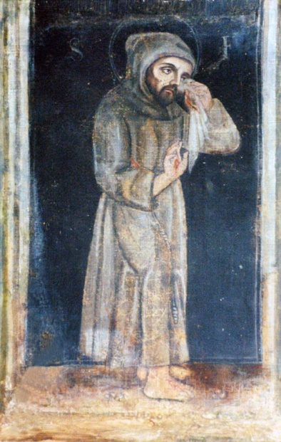
He then started the arduous work of rebuilding San Damiano by hand. It was a task that others would join him in. Others were inspired to join in this work and within a few years, thousands of men and women across Europe were following Francis’ way of life. What Francis had imagined as his personal response to Christ and the rebuilding of a single became a movement that was changing and rebuilding the Church writ large.
Francis answered the question, “Who do you say that I am?” by turning his whole way of life to that of Jesus’. The changes he made were so transformative and inspiring that others would join him on his journey. It also frightened the powers of the Church so much that they did all in their power to isolate and co-opt him. They were so effective that it is seldom you see an image like this one of St. Francis. You are more likely to see Francis feeding or preaching to birds; a mere garden ornament. That is why the saying goes “St. Francis is the most revered and least emulated of all the saints.”
We each have the opportunity to answer Jesus’ question. We should not be comfortable in ourselves until our lives match our words, until we are able to say as Peter did “You are the Messiah, the Son of the living God.” and have it be seen in how we live each day. Francis and Peter did not just talk the talk, they also walked it. Or as St. Francis said, “Preach the Gospel at all times, and when necessary use words.”
In the words of the General Thanksgiving from the Book of Common Prayer, may “we show forth your praise, not only with our lips, but in our lives, by giving up our selves to your service, and by walking before you in holiness and righteousness all the days of our lives.”
How we answer Jesus’ question and how we live into it makes all the difference for each of us and for the whole world.

Omer Englebert. St. Francis of Assisi: A Biography. [Cincinnati: St. Anthony Messenger, 1965] p36.
A simplified version of the more accurate quote, “It is no use walking anywhere to preach unless our walking is our preaching.”
The Book of Common Prayer, p. 125

